COMPUTER SCIENCE FUNDAMENTALS AND CAREER PATHWAYS

Assignment 2

TOPIC : Basis Of Linux And Open-Source Tools

NAME : Dolare Shruti Manohar

ROLL NO: 2501730066

COURSE: BTech CSE (AI ML)

SECTION : C

INTRODUCTION
- Just like windows, IOS, and Mac Os, Linux is an operating system. Its security, speed, flexibility and open source makes it the first choice for developers.
- Most modern technologies run on linux because it handles workload without crashing.
- Linux also gives user complete control over the system. Linux allow system control through commands.
- Shell scripting is one of the strongest parts of linux. A shell script allows user to automate repetitive tasks with just a few lines of code. Instead of manually typing long commands again and again.
- Shell scripting is widely used in system administration, backups, server maintenance, monitoring, automation. It helps reduce human errors, saves time and improves productivity.
- In this assignment, I learned how to install linux, use shell commands and create simple shell scripts.
- These skills are useful for coding, automation and working with servers in real job.
LINUX INSTALLATION

- Install VIRTUAL BOX :
- To use any other operating system in windows we need to install virtual box.
- Virtual box can be installed through this link https://www.virtualbox.org/
- Accept all the default options and click next.

- Download UBUNTU DESKTOP:

- Download the latest version https://ubuntu.com/download/desktop

- To open Linux Follow the steps:

Step 1: Click on new in machine to create new

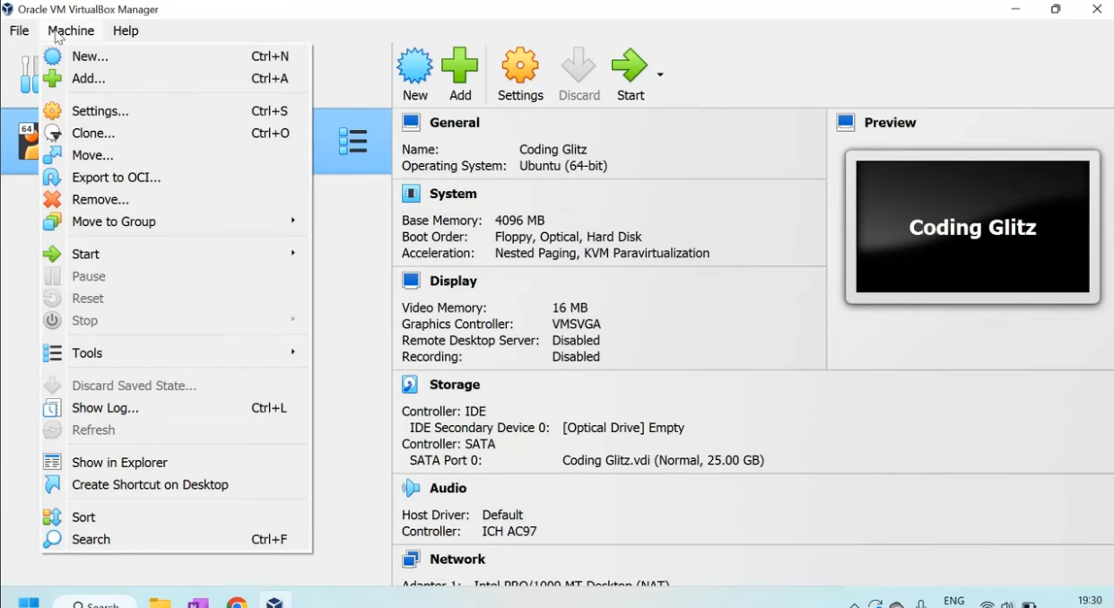

Step 2: Provide name for your machine.
Select type: LINUX
Select the vesrion: Ubuntu (64-bit)
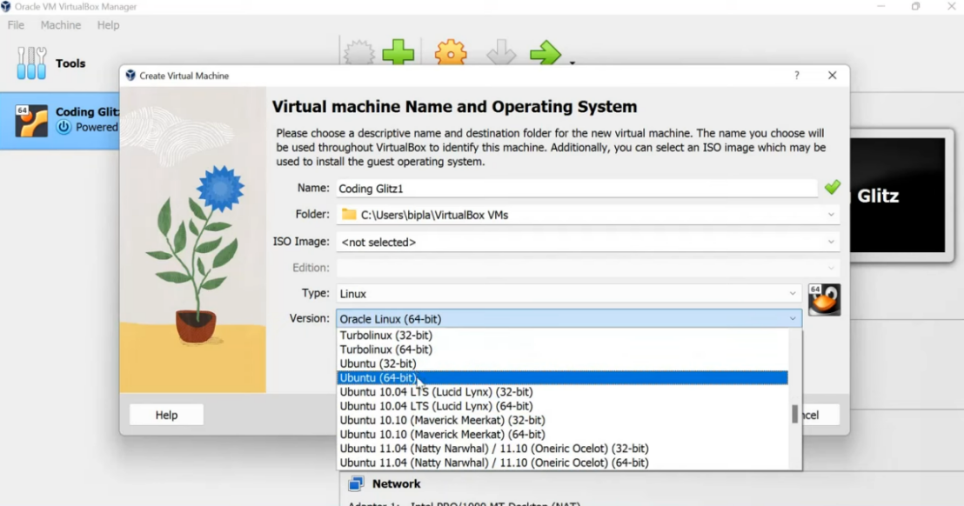
Step 3: Select required size.
Step 4: Allocate disk space according to your system. Confirm and click Finish.
Step 5: Click on START.
Step 6: Once the virtual box is installed select the downloaded location of ubuntu. Click Mount and Retry boot.
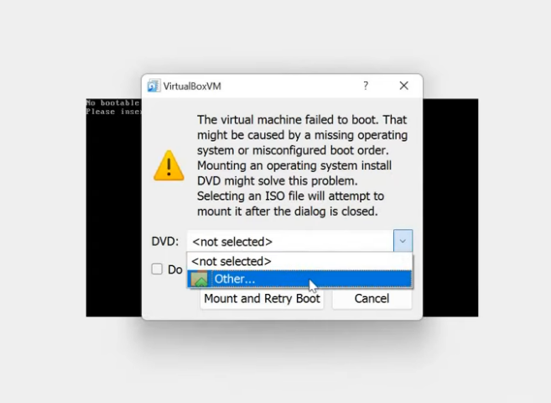
Step 7: Enter try or install ubuntu. Click on install ubuntu.
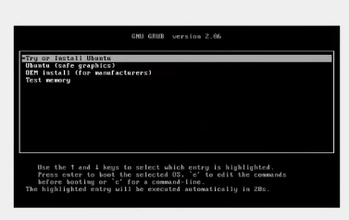
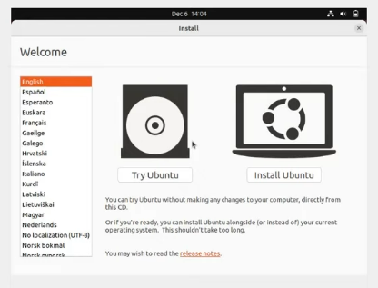
Step 8:
- Select english
- Continue with basic options.
- Select erase disk and install ubuntu. Continue to select timezone.

- Fill the required data; Name, password etc.
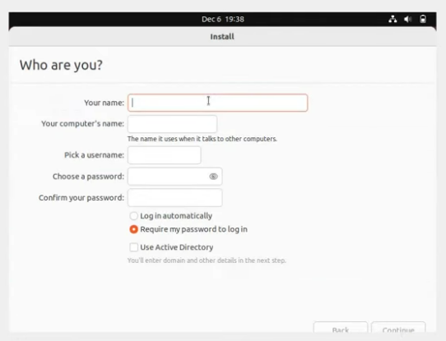

Step 9: Linux is Installed. Login later using password.
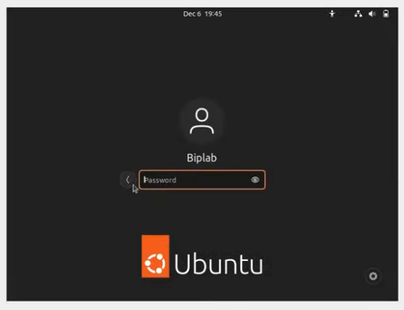

Shell commands
1. Cd: “Change Directory” is a fundamental command-line utility used to navigate the file system. It allows user to change their current working directory in the terminal.
Cd/ path - Go to specifoc folder
cd.. - go one level up
cd - go to home directory

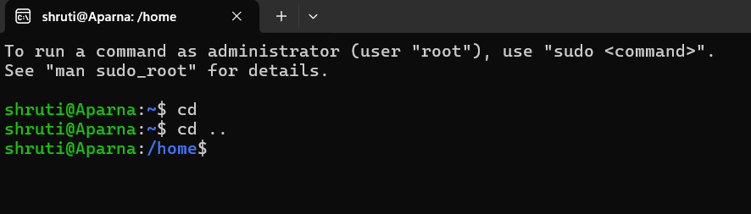

- pwd: Print current working directory.
Tells you exactly where you are in the
file system hierarchy.
pwd stands for: “print working directory”

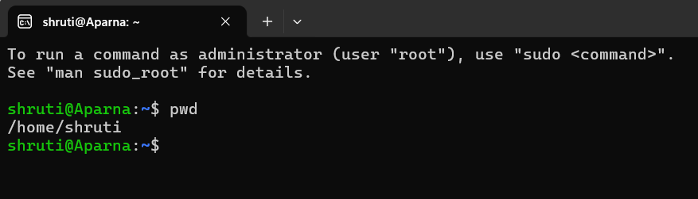

- ls : The ls command is a fundamental utility used to list the content of directories.
When executed without any arguments, it displays the files and subdirectories within the current working directory in alphabetical order.
ls- list files/folders
ls-l- detailed view
ls-a- show hidden files

- Tree:
Description: Display directory structure
Syntax: tree
Usage: shows folder hierarchy visually.

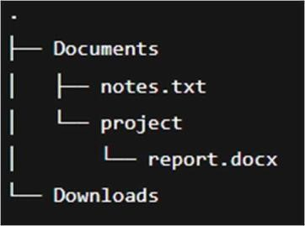

- mkdir:
Description: creates new directory
Syntax: mkdir test_folder
Usuage: Creates a new folder named test_folder

- cp :
Description: Copies files or directories
Syntax: cp info.txt info2.txt
Usage: copies .info.txt to info2.txt

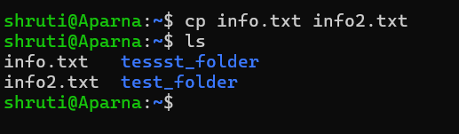

- Mv:
Description: Moves or rename files
Syntax: mv info2.txt test_folder/
Usage: movers info2txt to test_folder/

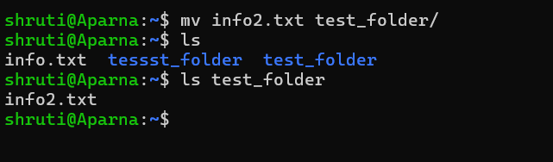

- rm:
Description: Removes files or directories
Syntax: rm test_folder/info2.txt
Usage: Deletes info2.txt peranently

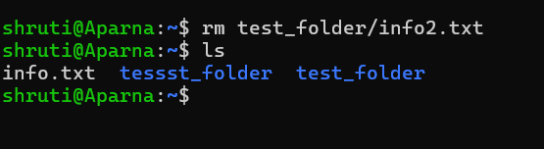

- chmod:
Description: changes file permissions
Syntax: chmod 755 script.sh
Usage: gives read, write, execute permissions

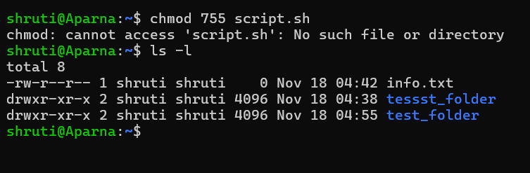

- chown:
Description: changes files owernship
Syntax: sudo chown user.user file.txt
Usage: transfer file ownership to specified user

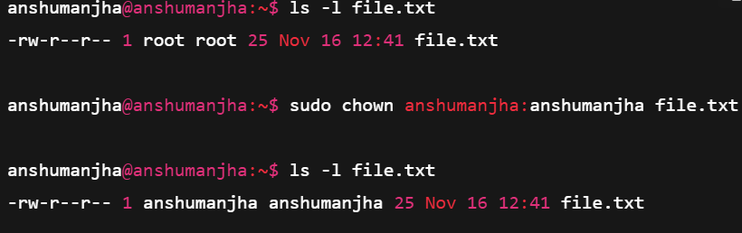

- Touch:
Description: Creates new file
Syntax: touch info .txt
Usage: creates an empty file

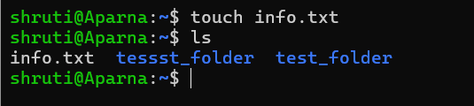

- ps:
Description: displays active processes
Sysntax: ps aux
Usage: shows all running processes

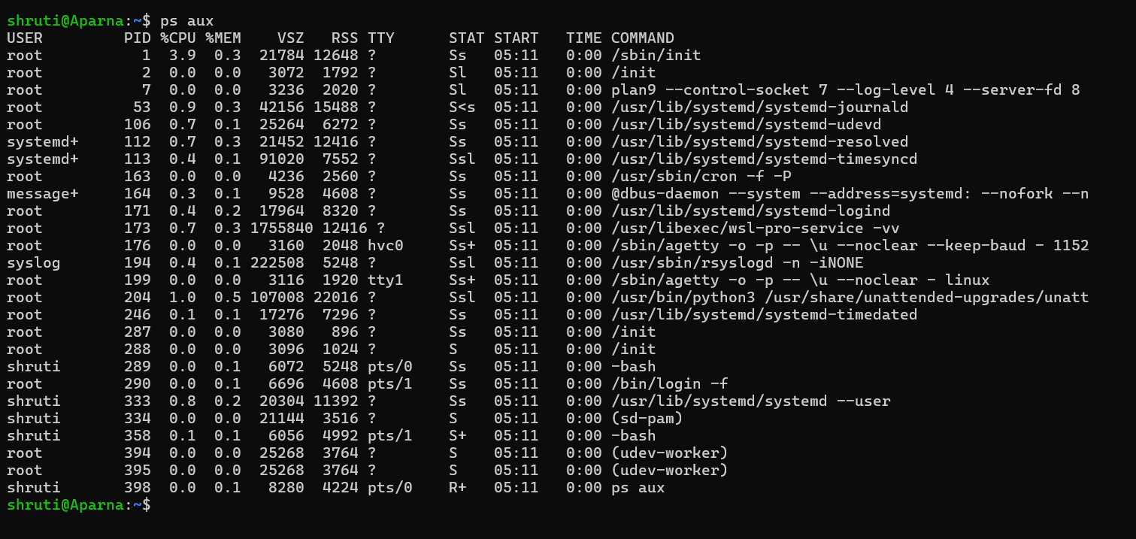

- top:
Description: monitors system processes
Syntax: top
Usage: displays real-time system usage

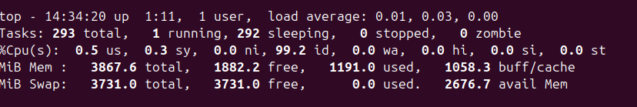

- Kill:
Description: terminates a process
Syntax: kill 1234
Usage: stops the process with PID 1234

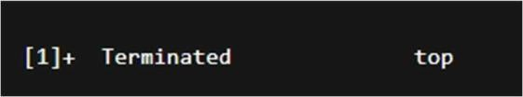

- ping:
Description: Tests network connectivity
Syntax: ping google.com
Usage: sends ICMP packets to test connection

- ifconfig:
Description: Displays network connection
Syntax: ifconfig
Usage: shows IP add and interface details

- ip:
Description: manages network interfaces
Syntax: ip addr show
Usage: displays all network interfaces and addresses
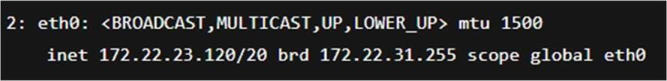

- netsat:
Description: show statistics
Syntax: netstat -tuln
Usage: lists all active network connections.

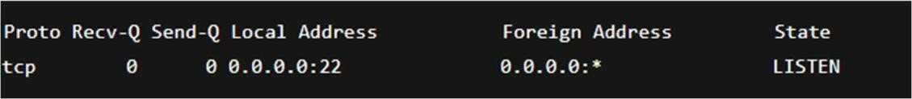

- history:
Description: displays command history
Syntax: history
Usage: lists all previously used commands.

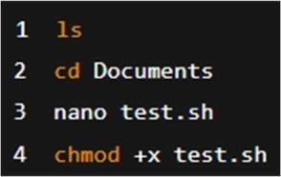

- clear:
Description: clears terminal screen
Syntax: clear
Usage: removes clutter from terminal view.
(Terminal screen clears- no output)

Shell script development

- Backup a directory:

#!/bin/bash
#Author: Shruti
#Date: 18-11-2025
#Purpose: backup a directory to backup folder with timestamp

src_dir= “$1”
backup_dir= “/home/$USER/backup”
timestamp=$(date+%Y%m%d_%H%M%S)

mkdir -p “$backup_dir”

cp -r “$src_dir” “$backup_dir/backup_$timestamp”
Echo “Backup completed successfully at $backup_dir/backup_$timestamp”

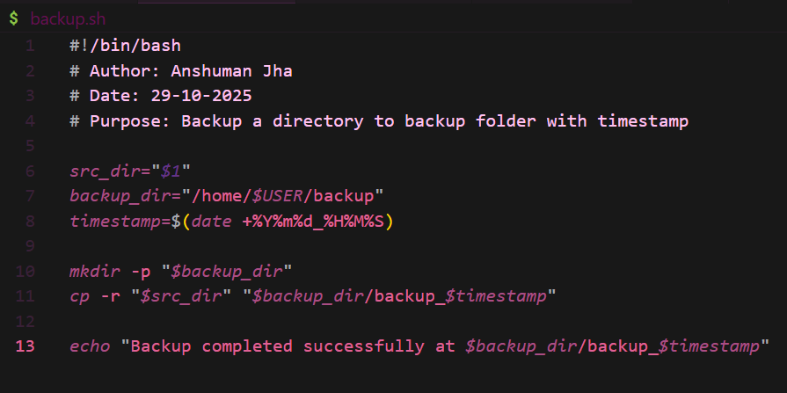

- CPU/Memory Monitoring :

#!/bin/bash
# Author: Anshuman Jha
# Date: 29-10-2025
# Purpose: Log CPU & Memory usage every 1 minute

logfile="/home/$USER/system_usage.log"

while true; do
echo "$(date): CPU & Memory Usage" >> "$logfile"
top -b -n1 | head -n 5 >> "$logfile"
echo "---------------------------------" >> "$logfile"
sleep 60
Done

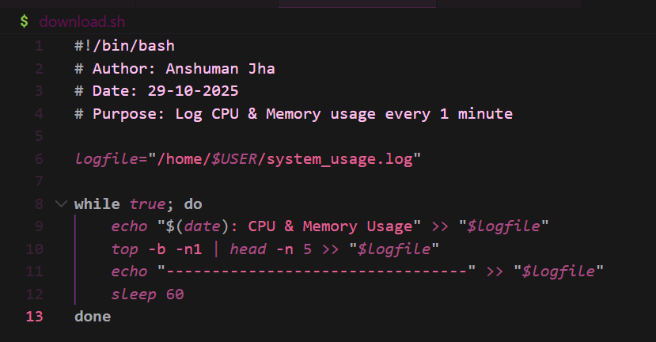

- Automated Download Task :
#!/bin/bash
# Author: Anshuman Jha
# Date: 29-10-2025
# Purpose: Download a file automatically

url="https://example.com/samplefile.zip"
dest="/home/$USER/Downloads"

mkdir -p "$dest"
wget -P "$dest" "$url"

echo "Download completed and saved to $dest"

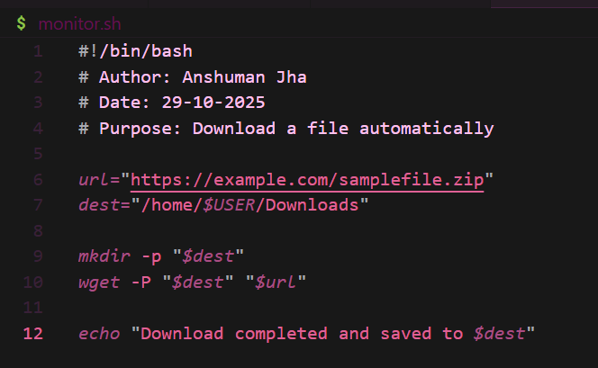

Github link: https://github.com/Shruti-codes27

REFLECTION

This assignment enhanced understanding of Linux environment management, commandline utilities, and automation using shell scripting. Challenges included handling permissions and debugging shell scripts. Through this exercise, I learned to effectively use Linux for real-world automation, backups, and system monitoring — essential skills for future software and AI projects.

